
Standard 4. Evaluation Plan.
Task 1.
Unit: | “The arts and their influence” | Subunit:
General Objective of the Unit: |  | To develop receptive and productive skills such as reading, listening, writing and speaking throughout different activities related to arts and their influence in culture.

Learning Goals | Purpose | Modalities, Activities & Instruments
To comprehend general and specific ideas in a text about important music festivals | Diagnostic | It will be done with the students’ previous knowledge about the festivals they may know. This is to know whether students know any Chilean or international music festival. To do so students’ knowledge will be elicited by asking them to match some famous music festivals with a type of music in their course book.  The students will have to work in pairs and answer some questions about the pictures they see.  The evaluation modality in this case will be hetero evaluative since the teacher will be in charge of checking the answers that students will give.  The evaluation guideline will be the possible answers that students may give since some of the questions are related with their personal appreciation and opinion and the correct answers in the teacher’s book.
 | Formative | The students answer some Wh-questions with their own words and multiple choice questions, using their copybooks and their course book, while they read a text about a festival called Womad.  The students describe a famous festival they know including the type of music played at that festival and the activities people can do there.  The evaluation modality will be hetero evaluative and co-evaluative, because the teacher will assess students’ answers according to the text, and students will assess each other and compare answers according to what they read in the text.  The evaluation guideline will be the correct answers given by the teacher’s book and the possible students’ answers based on their previous knowledge regarding to festivals.  See #Figure1 and #Figure2 in annexes.
 | Summative | There will not be summative evaluation.
To comprehend specific information in a spoken quiz related to musical genres.  To express personal opinions and preferences about music. | Diagnostic | The diagnostic will be done with the students’ previous knowledge regarding musical genres. This is to know whether students know any of the musical genres that exist nowadays. The teacher elicits students’ previous knowledge regarding musical genres asking them to name a famous singer they know for each of the musical genres written on the board.  The evaluation modality will be hetero evaluation and co-evaluation since the teacher will evaluate the answers according to some possible answers that students may say, and students will evaluate each other answers according to their knowledge about each musical genre.  The evaluation guideline will be the possible answers that students may say according to their previous knowledge.
 | Formative | In the course book The students complete some questions in a written quiz using questions words and they choose the correct answer for each question while they listen to the same written quiz. On this activity students are asked to comprehend specific information in order to complete a quiz.  The student work in pairs or in groups of 3 and discuss giving their opinion and preferences about some questions related to music. On this activity students must try to express their personal opinion and preferences according to each question.  The evaluation modality will be hetero evaluative, because the teacher will evaluate students ‘answers according to an evaluation guideline provided in the teacher’s book and possible answers that students may have for open questions.  Moreover; co-evaluation will also be applied since students will be allowed to compare each other answers, discuss and share their opinion.  See #Figure3 and #Figure4 in annexes.
 | Summative | There will not be summative evaluation.
To comprehend general and specific information in a spoken interview about urban art.  To express preferences regarding some activities utilizing likes and dislikes expressions. | Diagnostic | It will be carried out with students’ previous knowledge about the topic of the lesson in order to know how much they know about it. I will do that eliciting what they may know about graffiti and important people who do this urban art. This will be orally. Students will also be asked to look at a picture about graffiti and answer orally what they know about what the teacher ask them.  There will be hetero evaluation since the teacher will evaluate what the students say according to the information he has.  The evaluation guideline will be based on the possible answers and opinions that students may have, and the information that the teacher has about the topic.
 | Formative | The students will have to listen to a recording about a famous artist who paint graffities in Valparaiso and take notes about specific information. This is to develop students’ listening comprehension of specific and general information too.  Students will also be asked to look at 2 pictures regarding graffiti and discuss in pairs some questions for then express their opinion with their own words. This is meant to be an opportunity for students to discuss and share their opinions regarding the topic using their own words.  It will be elicited and introduced likes and dislikes expressions in order to show students some expression that they could use to talk about something they like or don’t like.  Students will be asked to write some sentences using the verbs given and likes and dislikes expressions.  The evaluation modality will be hetero evaluation since the teacher will evaluate some activities according to the evaluation guideline.  There will also be co-evaluation, because students will be able to evaluate each other in the activities where they have to give personal opinions or information.  See #Figure5 and #Figure6 in annexes.
 | Summative | Students will be asked to write a famous singer profile according to a guideline. This summative evaluation is related with the lessons in which the topic had to do with music. The purpose of this task is to make students search and read information related with what they study in previous lessons and also to teach them to synthetize information according to what they were required to do.  The evaluation modality will be hetero evaluation according to an evaluation guideline since the teacher will evaluate the report according to what he required students to do. It will be assigned a specific score to each of the parts in the report, and there will be a 60% of requirement.
To comprehend general and specific information in a spoken conversation about films and books.  To order specific information in a written conversation while listening. | Diagnostic | The students will be asked to discuss in pairs some questions about the film and book called Alice in wonderlands and their preferences between films and books. The purpose of this activity is to elicit students’ previous knowledge about the book or film Alice in wonderlands and to know their preferences regarding books and films.  The evaluation modality will be hetero evaluation since the teacher will evaluate students’ answers according to what he knows in order to guide the discussion and correct what students may say.  This activity focuses on discussion; thus, there are no correct answers. The evaluation guideline will be based on the possible answers that students may give.
 | Formative | The students are asked to listen to a conversation and put it in order while they listen to it. This activity tests students’ comprehension where they will have to try to comprehend general and specific information in order to know what the correct order is.  Students will be asked to do an activity where they will have to choose the correct adjective in some sentences. This is to know whether students remember what adjectives are, and whether they remember some of them.  Students are sked to discuss in pairs some statements, and to check the ones they are agree with, cross the ones they are not agree with, and defend their opinion to their partners. This is to review some comparative adjectives related with the topic.  There will be hetero evaluation, because the teacher will evaluate students’ answers, in some cases, according to an evaluation guideline.  There will also be co-evaluation since in some cases students will evaluate each other answers according to the previous knowledge they have.  See #Figure7 and #Figure8 in annexes.
 | Summative | There will not be summative evaluation.
To comprehend general and specific information in a recording about social networking  To complete some sentences while listening. | Diagnostic | Students will be asked to discuss in pairs about how social networking help teenagers express themselves. This is to know students’ opinions about the topic and how much they know about social networking.  Students will be asked to tick the words they think they will hear.  The evaluation modality will be hetero evaluation since the teacher will evaluate students’ answers according to an evaluation guideline.
 | Formative | Students will be asked to listen to a recording and check the predictions they made.  Students are also asked to listen again and complete the sentences while they listen to it. These activities intend to test students’ comprehension of general and specific information when listening.  Students are asked to do a survey of their classmates regarding social networking. This is intended to make students collect information from their classmates in order to know about each other about social networking.  It will be applied a hetero evaluation since the teacher will evaluate according to an evaluation guideline with the correct answers.  See #Figure9 and #Figure10 in annexes.
 | Summative | There will not be summative evaluation.
To apply and use what it was learn in previous lessons answering an evaluation test.  -To complete a dialogue while listening a recording.  -To answer multiple choice questions while listening a recording.  -To answer multiple choice questions while reading a text.  -To answer open questions while reading a text.  -To match certain vocabulary with some pictures. | Diagnostic | There will not be diagnostic since it is an evaluation test.
 | Formative | There will not be diagnostic since it is an evaluation test.
 | Summative | There will be an evaluation test. The test will be intended to measure the unit 2.  Students will be asked to:  -Match vocabulary with their meaning.  -Match likes and dislikes expressions with their meaning.  -Create simple sentences using verbs assigned and like and dislikes expressions.  -Listen to a recording about one of the topics studied in the unit and answer multiple choice questions and open questions based on general and specific information in the recording.  -Read a text related with one of the topics studied in the unit, and answer multiple choice questions and open questions based one general and specific information in the text.  The evaluation modality will be hetero evaluation since the teacher will evaluate the test according to an evaluation guideline. There will be 60% of requirement.

Task 2.
The evaluation plan presented was designed with the intention to evaluate the grade of development in English skills such as reading and listening. The evaluation plan proposed is intended to evaluate skills development as a process; Thus, the activities are designed to measure students’ ability to do something specific such as comprehend specific information in a conversation, express personal opinions, give recommendation, etc. Therefore, I think that each activity was design to measure the learning goal expected in each lesson. However, it is needed more time to see a significant grade of development in each skill since it is a process that requires a lot of practice. I think that these type of activities serve to the purpose of evidence the grade of development in English skills, but not that much in a short time.
To design the evaluation plan was relevant to consider the hours of English that students have per week, the type of lesson planning to develop English skills, the context where students were, the planes y programas de Ingles, and the resources available to teach. These factors influenced on the decisions I made since I had to choose only the important and relevant things to do, because of the time available, the resources, and the context in which English is not considered important by students. I had to consider these factors in order to adapt the contents leaving some things out, because of time and my guide teacher requirements.
The students may use the information from the evaluations as feedback and evidence of their progress in order to know how well their English skills are and how much they need to improve.

Task 3.
The evaluation plan presented may attend to students’ diversity, but not to all of them. The evaluation have different types of activities in order to attend students’ diversity, but it may not be enough for all the students since some students may need other type of practice. This situation may imply a challenge to help students to develop the activities since these type of activities may not be considered attractive or interesting by some of them. In order to attend to this diversity I will adapt some activities or provide more support to those students in order to assist them to do the activities.

Annexes.
Figure1. Activities
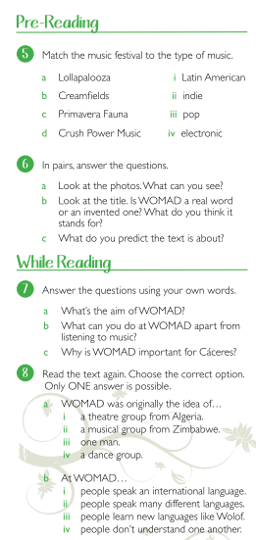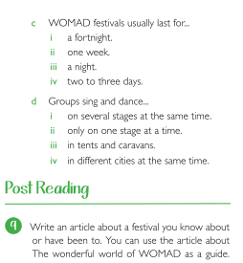

Figure 2. Evaluation Guideline.
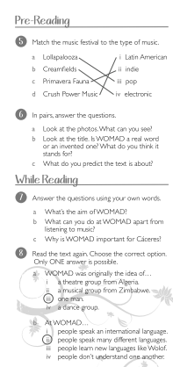
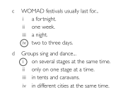

Figure 3. Activities.
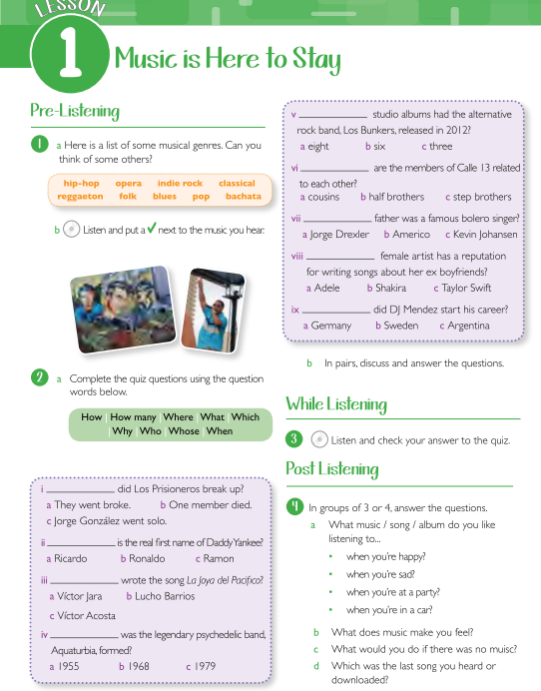

Figure 4. Evaluation guideline.
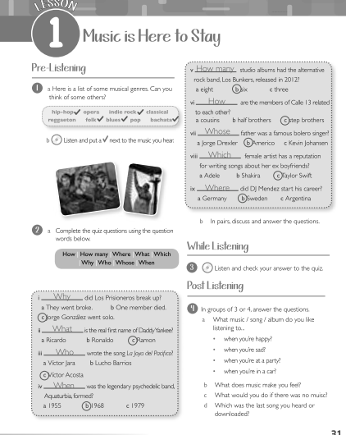

Figure 5. Activities.


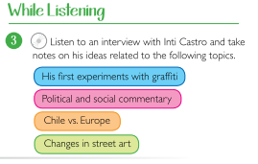
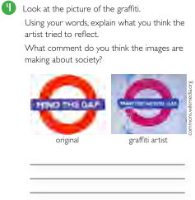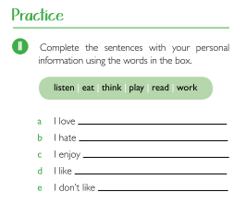
Figure 6. Evaluation guideline
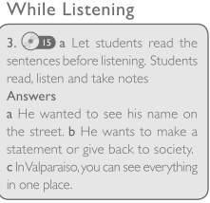
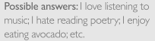

Figure 7. Activities.
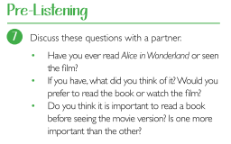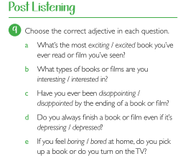
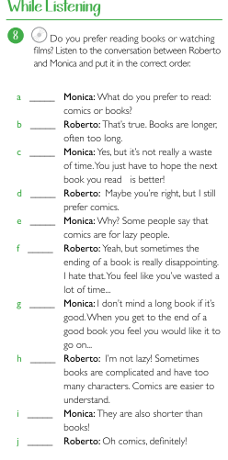
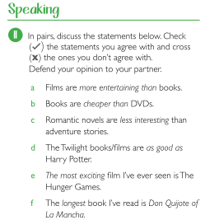

Figure 8. Evaluation guideline.
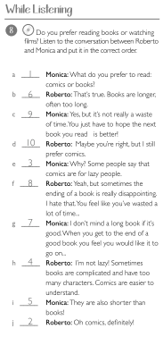

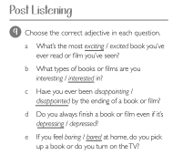

Figure 9. Activities.
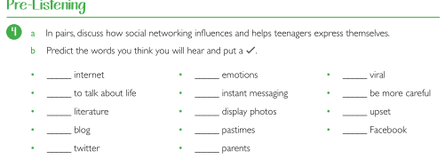
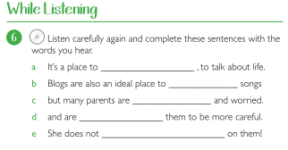
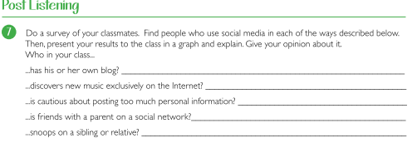

Figure 10. Evaluation guideline
